
Teatro Musical En-cantado presents
The Apprentice and the 7 Tasks

An introduction for children and their families to a classical music
experience, combining a symphony orchestra (or a trio of violin,
piano and double bass), with a story format, two actors, dancer,
and shadow theater to create a magical adventure.

PRODUCTION: Rafael Rodríguez & Laurie Saunders
MUSICAL ARRANGEMENTS: Judith González & Laurie Saunders
SCRIPT: Alberto Palavicini & Laurie Saunders
A symphony orchestra (or a trio of violin, piano and double bass), shares the stage with a wizard’s study and a shadow theater (which measures 15 wide by 7.5 feet high). Each familiar selection of classical music is explained by the wizard and represents a task which the apprentice must accomplish. While the music is performed the actors and dancer enact each fantasy utilizing a shadow theater creating a magical experience for young children and their families.

The concert lasts 50 minutes and is appropriate for children five years and older.

Performances are available in both
English and Spanish.

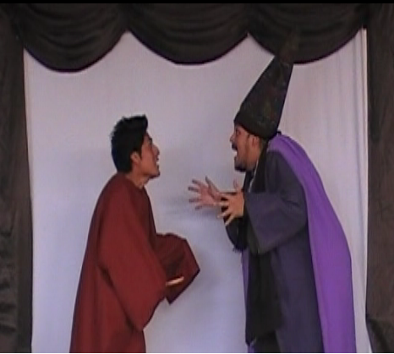

PROGRAM:

La Traviata  The Sorcerer’s Apprentice  In the Hall of the Mountain King  Phantom of the Opera  El Amor Brujo  Melody  Valse Triste  Funeral March  Dance Macabre  Hornpipe | G. Verdi  P. Dukas  E. Grieg  A.L. Weber  M. de Falla  C.W. Gluck  J. Sibelius  L. VanBeethoven  C. Saint-Saens  G.F. Handel

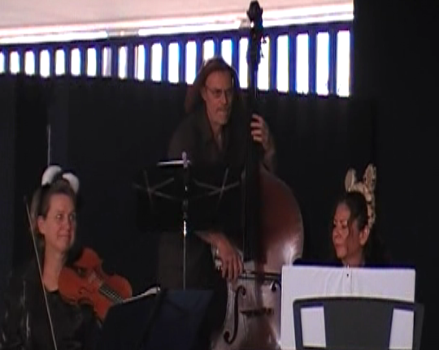

The wizard explains to his apprentice that he has just cast a spell on an overcrowded subway car and changed the passengers into a symphony orchestra (or a parrot, cat and lizard into a violinist, pianist and double bassist), which will help the apprentice complete his tasks in order to earn his book of spells and magic hat and become a wizard.

The apprentice must spend one night with the trolls (In the Hall of the Mountain King), deliver a magical mirror to the phantom at the opera house (Phantom of the Opera), free a tortured spirit that haunts a couple in love (Amor Brujo), enter the Greek world of Hades and rescue a maiden (Melody), dance a waltz with a dying woman (Valse Triste), carry a coffin to the graveyard (Funeral March), and finally, spend a night in the graveyard (Dance Macabre).

Will he accomplish all his tasks?

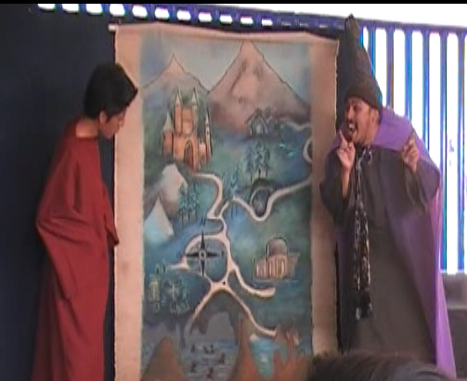

CAST:
Laurie Saunders -  Rafael Rodríguez -  Judith González -  Alberto Palavicini -  Gabriel López -  Roxana Rodríguez - | Violin  Double bass  Piano  Actor  Actor  Actress / Dancer

Technical Requirements:
This concert needs to be performed at night when it’s outdoors or in a theatre.
- Stage 10m x 8m (minimum)
- Piano (if there is no piano, we can use our keyboard)
- 4 electrical outlets
- 2 small tables
- 5 chairs
- Lighting technician
- Access to the stage at least 6 hours before the presentation
- 3 dressing rooms with bathrooms

LIGHTS:  - 8 Leecko  - 10 par etc  - 4 Fresnell  - 1 par 63 with a stand | AUDIO:  - 3 microphones Shure 57  - 3 mic stands  - 2 headset microphones  - 1 audio console  - 2 speakers

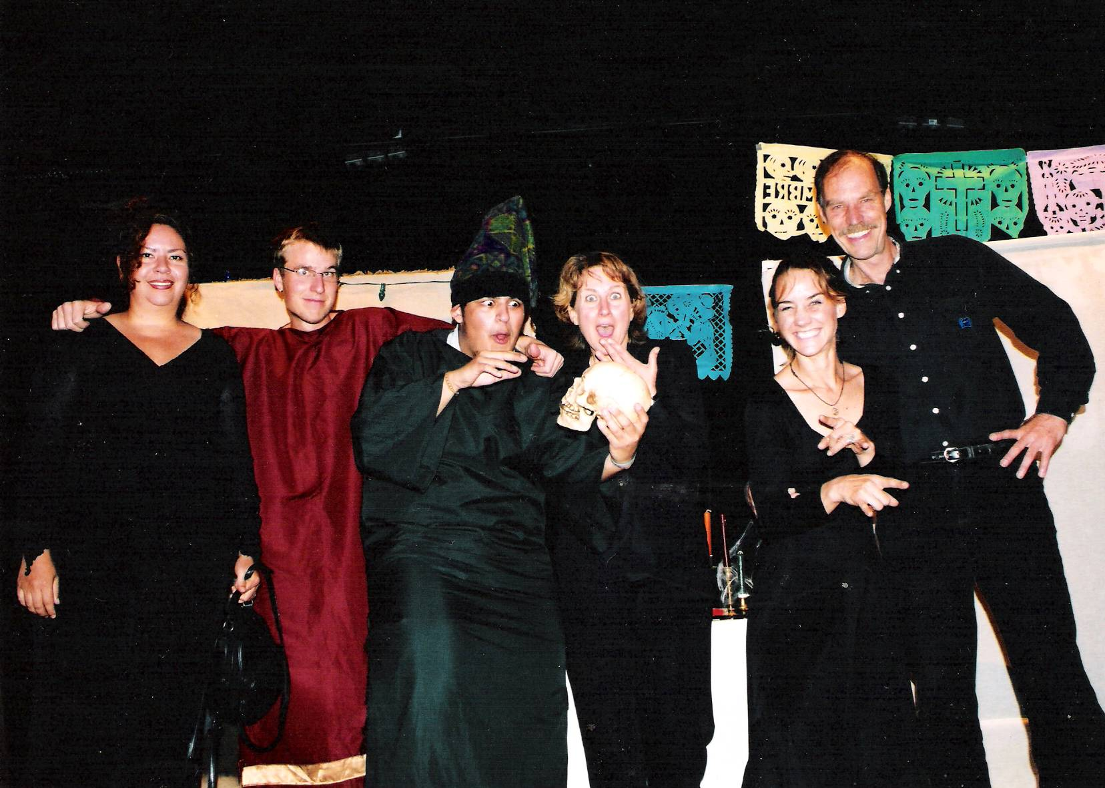

CONTACT: Rafael Rodríguez & Laurie Saunders
Camino a Huitzilac Km1
Huertas San Pedro
Huitzilac, Morelos

teatro.musicinmexico.com
camerata@musicinmexico.com
001- 52 - 777-221-0006
001 -52 - 739-393-0749
Id: 62*199827*2

RFC: ROAR470206-P48

*This concert is appropriate for children 5 years and older.
*This concert is 50 minutes long with no intermission.

PRODUCTION: Rafael Rodríguez & Laurie Saunders
MUSICAL ARRANGEMENTS: Judith González & Laurie Saunders
SCRIPT: Alberto Palavicini & Laurie Saunders

Previous performances:

- Plaza Principal, Xoxocotlan, Oaxaca
- Museo Regional del Niño, Sta. Ana del Valle, Oaxaca
- Casa de la Cultura, San Juan Ixcaquixtla, Puebla
- Casa de la Cultura, Cuautinchán, Puebla
- Teatro Xicoténcatl, Tlaxcala, Tlaxcala
- Centro Cultural, Zacatelco, Tlaxcala
- Centro Cultural de Nezahualcoyotl, Estado de México
- Centro Cultural Regional de Texcoco, Estado de México
- Salón de Actos, San Agustín Taxiaca, Hidalgo
- El Mexquital, Hidalgo
- Teatro Benito Juárez, México, D.F.
- Palacio de la Cultura, Chilpancingo, Guerrero
- Museo de la Isla de Cozumel, Cozumel, Quintana Roo
- Feria de la Cecina, Yecapixtla, Morelos
- Jardín Borda, Cuernavaca, Morelos
- Jantetelco, Morelos
- Feria de la Primavera, Plaza Loreto, México, D.F.
- Feria del Pulque y Barbacoa, Huitzilac, Morelos
- Feria del Jitomate, Achichipico, Morelos
- Colegio Suizo Americano, Cuernavaca, Morelos
- Colegio Porter, Cuernavaca, Morelos
- Colegio Marymount, Cuernavaca, Morelos
- Librería Gandhi, Cuernavaca, Morelos
- Feria de Tlaltenango, Cuernavaca, Morelos
- Feria Internacional de las Almas, Valle de Bravo, México

Reviews:

“Excellent, marvelous, and unforgettable presentation. Respect for concert repertoire. Impeccable execution, the actors and actress fun and lively, a very professional performance.” Centro Cultural Regional de Texcoco.

“Excellent and impressive level of performance. Utilizing the shadow theater as a means of explaining the meaning of the music, captivated the audience, making them feel a part of the presentation.” Centro Cultural de Nezahualcoyotl.

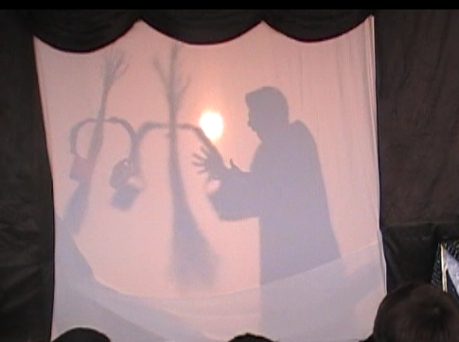

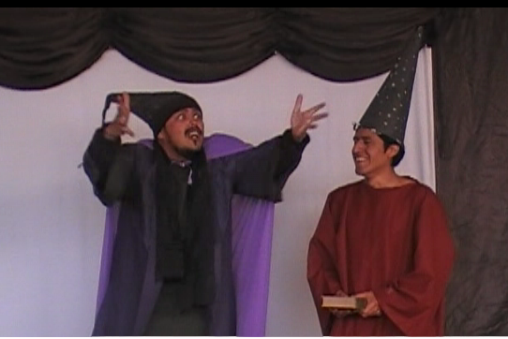

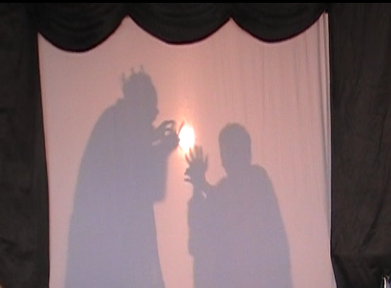

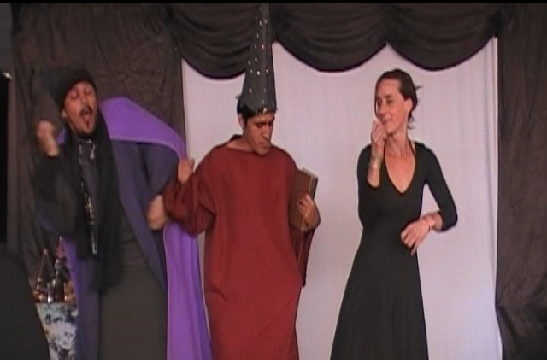

The musical theater group EN-CANTADO was founded in Mexico City in the year 1999 by Laurie Saunders, violinist and Rafael Rodriguez, double bassist, who draw from 20 years of professional experience as members of The Symphony Orchestra of the State of Mexico, the Philharmonic Orchestra of the National Autonomous University of Mexico, the Opera Orchestra of Fine Arts in Mexico City, the Camerata Mexicana, and the Camerata de Oro. Interested in educating future classical music lovers, they enjoy writing and performing concerts for young people.
While teaching at the University of Texas, the University La Salle, and the University of Mexico, they found that students enjoy classical music when it is presented in an enjoyable, interesting, understandable format.

The musical theater group EN-CANTADO has presented concerts in arts festivals, museums, schools and universities throughout Mexico and also has attended cultural events representing the state of Morelos. In 2006 the company was awarded a national grant to perform throughout seven states in Mexico.



